PYTHON LAB CYCLE
Muhammad Anshad P A
MCA2336

1. Python Programming
1.1. Create a simple calculator in Python.
PROGRAM:
#Simple Calculator

num1 = float(input('Enter the first Number : '))
num2 = float(input('Enter the second Number : '))
op = input('Select the operator : \n+\n-\n*\n/\n')

if op == '+' :
sum = num1 + num2
print('Sum of two numbers is ',sum)
elif op == '-' :
diff = num1 - num2
print('Difference of two numbers is ',diff)
elif op == '*' :
prod = num1 * num2
print('Product of two numbers is : ',prod)
elif op == '/' :
if num2 == 0 :
print('Division by zero Not possible')
div = num1 / num2
print('Division : ',div)
else :
print('Invalid input')

OUTPUT:
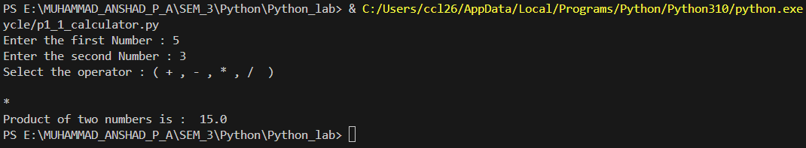

1.2. An electric power distribution company charges domestic customers as
follows: Consumption unit Rate of charge:
1.2.1. 0-200 Rs. 0.50 per unit
1.2.2. 201-400 Rs. 0.65 per unit in excess of 200
1.2.3. 401-600 Rs 0.80 per unit excess of 400
1.2.4. 601 and above Rs 1.00per unit excess of 600
1.2.5. If the bill exceeds Rs. 400, then a surcharge of 15% will be charged,
and the minimum bill should be Rs. 100/-
Create a Python program based on the scenario mentioned above.

PROGRAM:
#Function to calculate Bill
def billCalculator(cUnits):
if cUnits <= 200:
bill = cUnits * 0.50
elif cUnits <= 400:
bill = (200 * 0.50) + (cUnits -200) * 0.65
elif cUnits <= 600:
bill = (200 * 0.50) + (200 * 0.65) + (cUnits - 400) * 0.80
else:
bill = (200 * 0.50) + (200 * 0.65) + (200 * 0.80) + (cUnits - 600) * 1.00

#Add surcharge to bill if bill amount > 400
if bill > 400 :
surCharge = (bill - 400) * 0.15
bill += surCharge

#If bill < 100 Make bill as 100
if bill < 100 :
bill = 100

return bill
print("\nProgram to calculate electric power consumption -->\n")

consumedUnits = float(input("\nEnter the units consumed : "))

totalBill = billCalculator(consumedUnits)
print(f"Total Bill : Rs. {totalBill}")

OUTPUT:
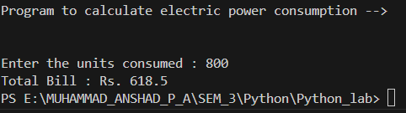

1.3. Print the pyramid of numbers using for loops.

PROGRAM:
#Program to display number Pyramid
def numPyramid(n):
for i in range(1 , n + 1):
for j in range( n - i):
print(" ",end ="") #To print leading spaces

for j in range(1 , i+1):
print(j ,end="") #printing num in ascending order

for j in range (i - 1 ,0 , -1):
print(j , end="") #print in desc order

print() # To move to next line

n = int(input("Enter how many no.of rows to display : "))
numPyramid(n)

OUTPUT:
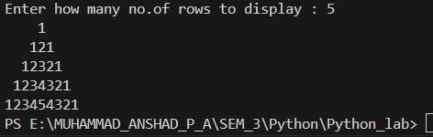

1.4. Write a program to find the number and sum of all integers greater than 100 and less than 200 that are divisible by 7.

PROGRAM:
#Program to find the number and
#Sum of all num > 100 and < 200 that are divisible by 7
def findNumAndSum():
count = 0
total_sum = 0

for num in range(101, 200):
if num % 7 == 0:
count += 1
total_sum += num

return count, total_sum

count, totalSum = findNumAndSum()
print(f"The number of integers greater than 100 and less than 200 that are divisible by 7 is: {count}")
print(f"The sum of all these integers is: {totalSum}")

OUTPUT:

1.5. Write a recursive function to calculate the sum of numbers from 0 to 10

PROGRAM :
#Program to calculate the sum of numbers from 0 to 10 using recursion
def recursiveSum(n):
# Base case
if n == 0:
return 0
else:
# Recursive case
return n + recursiveSum(n - 1)

result = recursiveSum(10)
print(f"The sum of numbers from 0 to 10 is: {result}")

OUTPUT:
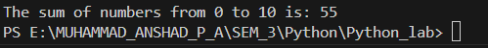

1.6. Write a Python program to reverse the digits of a given number and add them to the original. If the sum is not a palindrome, repeat this procedure.

PROGRAM :
#Write a Python program to reverse the digits of a given number and add them
#to the original. If the sum is not a palindrome, repeat this procedure.

def isPalindrome(n):
original = n
reverse = 0
while n > 0:
digit = n % 10
reverse = reverse * 10 + digit
n = n // 10
return original == reverse

def reverseNumber(n):
reverse = 0
while n > 0:
digit = n % 10
reverse = reverse * 10 + digit
n = n // 10 # It returns the quotient which is rounded down to the nearest integer.
return reverse

def reverseAndAddUntilPalindrome(n):
while not isPalindrome(n):
reversed_n = reverseNumber(n)
n = n + reversed_n
print(f"Reversed: {reversed_n}, Sum: {n}")
return n

number = int(input("Enter a number: "))
result = reverseAndAddUntilPalindrome(number)
print(f"The resulting palindrome is: {result}")

OUTPUT :
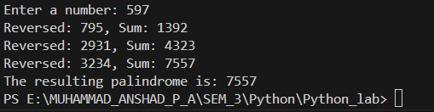

1.7. Write a menu-driven program that performs the following operations on
strings
1.7.1. Check if the String is a Substring of Another String
1.7.2. Count Occurrences of Character
1.7.3. Replace a substring with another substring
1.7.4. Convert to Capital Letters
PROGRAM :
#Write a menu-driven program that performs the following operations on
# strings
# 1. Check if the String is a Substring of Another String
# 2. Count Occurrences of Character
# 3. Replace a substring with another substring
# 4. Convert to Capital Letters

def checkSubstring():
string = input("Enter the main string: ")
substring = input("Enter the substring to check: ")

if substring in string:
print(f"'{substring}' is a substring of '{string}'")
else:
print(f"'{substring}' is not a substring of '{string}'")

def countOccurrences():
string = input("Enter the string: ")
char = input("Enter the character to count: ")

count = string.count(char)
print(f"Number of occurrences of '{char}' in '{string}': {count}")

def replaceSubstring():
string = input("Enter the main string: ")
old_substring = input("Enter the substring to replace: ")
new_substring = input("Enter the new substring: ")

new_string = string.replace(old_substring, new_substring)
print(f"Modified string: '{new_string}'")

def convertToUpper():
string = input("Enter the string to convert to uppercase: ")
uppercase_string = string.upper()
print(f"Uppercase string: '{uppercase_string}'")

# Main program
while True:
print("\nMenu:")
print("1. Check if String is a Substring of Another String")
print("2. Count Occurrences of Character")
print("3. Replace a substring with another substring")
print("4. Convert to Capital Letters")
print("5. Exit")

choice = input("Enter your choice (1-5): ")

if choice == '1':
checkSubstring()
elif choice == '2':
countOccurrences()
elif choice == '3':
replaceSubstring()
elif choice == '4':
convertToUpper()
elif choice == '5':
print("Exiting the program...")
break
else:
print("Invalid choice! Please enter a number from 1 to 5.")

OUTPUT :
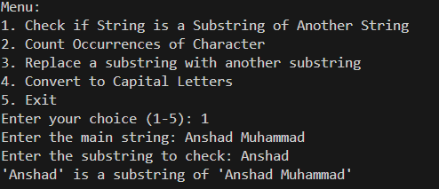
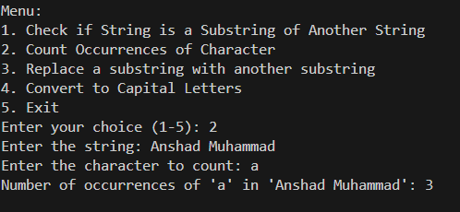
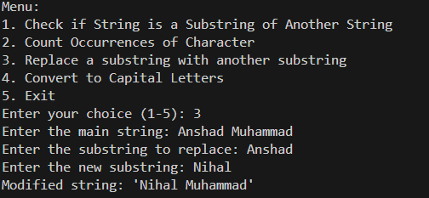

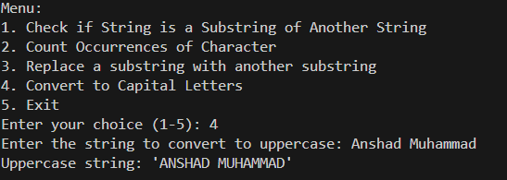

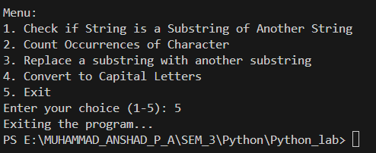

1.8. Write a function to find the factorial of a number but also store the factorials calculated in a dictionary.

PROGRAM:
#1.8. Write a function to find the factorial of a number but also store the factorials calculated in a dictionary.
def factorial_with_cache(n, cache={}):
if n < 0:
raise ValueError("Factorial is not defined for negative numbers.")
if n in cache:
return cache[n]
if n == 0 or n == 1:
result = 1
else:
result = n * factorial_with_cache(n - 1, cache)
cache[n] = result
print(cache[n])
return result

number = int(input("Enter a number to calculate its factorial: "))
factorial = factorial_with_cache(number)
print(f"The factorial of {number} is: {factorial}")

OUTPUT:
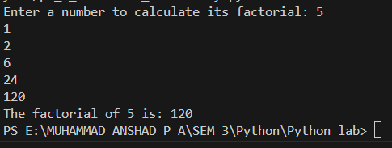

1.9. Perform various set operations
1.9.1. Set Union
1.9.2. Set Intersection
1.9.3. Set Difference

PROGRAM :
#Perform various set operations
# 1. Set Union
# 2. Set Intersection
# 3. Set Difference
def setOperations(set1, set2):

union_set = set1.union(set2)

intersection_set = set1.intersection(set2)

difference_set1 = set1.difference(set2)

difference_set2 = set2.difference(set1)

return union_set, intersection_set, difference_set1, difference_set2

set1 = {1, 2, 3, 4, 5}
set2 = {3, 4, 5, 6, 7}

union_set, intersection_set, difference_set1, difference_set2 = setOperations(set1, set2)

print(f"Set1: {set1}")
print(f"Set2: {set2}")

print(f"Union of Set1 and Set2: {union_set}")
print(f"Intersection of Set1 and Set2: {intersection_set}")
print(f"Difference (Set1 - Set2): {difference_set1}")
print(f"Difference (Set2 - Set1): {difference_set2}")

OUTPUT:
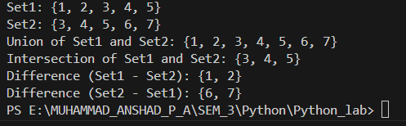

1.10. Create a dictionary to store the name, roll_no, and total_mark of N students.
Now print the details of the student with the highest total_mark.

PROGRAM :
# Create a dictionary to store the name, roll_no, and total_mark of N students.
#Now print the details of the student with the highest total_mark.

#lambda x: x['marks'] is a lambda function defined inline.
# It takes an argument x (which represents each student dictionary in students) and returns x['marks'].
# This lambda function extracts the 'marks' value from each student dictionary.
def student_details(N):
student=[]
for i in range(N):
print("\nEnter details of Student ",i+1," : ")
name = input("Enter student name: ")
roll_no=input("Enter the roll no:")
marks = int(input("Enter the marks: "))
students={
'name':name,
'roll_no':roll_no,
'marks':marks
}
student.append(students)
return student
def find_top_student(students):
top_student = max(students, key=lambda x: x['marks'])
return top_student
N=int(input("Enter the number of students:"))
Student=student_details(N)
print("Student Details:\n")
print(Student)
top_student=find_top_student(Student)
print("Details of Top Student:\n")
print("Name:",top_student['name'])
print("Roll No:",top_student['roll_no'])
print("Marks:",top_student['marks'])

OUTPUT :
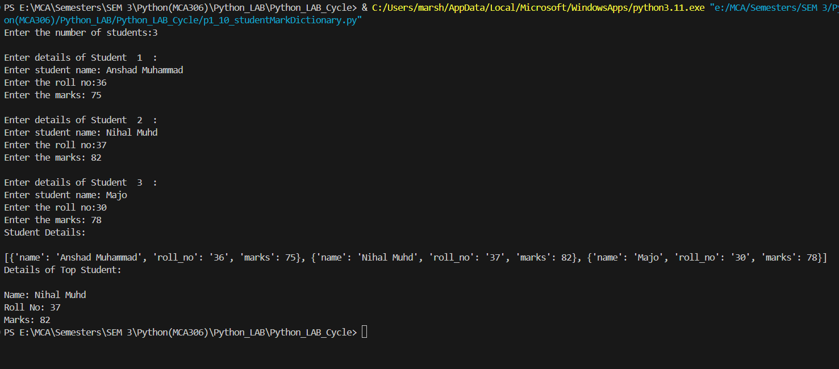

1.11. Write a Python program to copy the contents of a file into another file, line by line.

PROGRAM :
# Write a Python program to copy the contents of a file into another file, line by line.

# Function to copy contents from one file to another
def Copy(sourceFile, destinationFile):
try:
# Open the source file in read mode
with open(sourceFile, 'r') as src:
# Open the destination file in write mode
with open(destinationFile, 'w') as dest:
# Read and write each line from source to destination
for line in src:
dest.write(line)
print(f"\nContents are copied from {sourceFile} to {destinationFile} Successfully.")
except FileNotFoundError:
print(f"\nThe file {sourceFile} does not exist.")
except IOError as e:
print(f"An error occurred: {e}")
# Take input from user:
sourceFile = input("\nEnter the source file name: ")
destinationFile = input("\nEnter the destination file name: ")
Copy(sourceFile, destinationFile) #Calling method

OUTPUT:
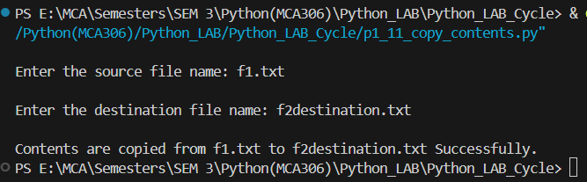
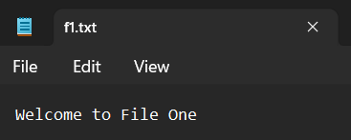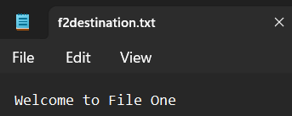

1.12. Use the OS module to perform :
1.12.1. Create a directory
1.12.2. Directory Listing
1.12.3. Search for “.py” files
1.12.4. Remove a particular file

PROGRAM :
#1.Use the OS module to perform
#1.1. Create a directory
#1.2. Directory Listing
#1.3. Search for “.py” files
#1.4. Remove a particular file

import os

def createDirectory(directory):
try:
os.makedirs(directory)
print(f"Directory '{directory}' created successfully.")
except FileExistsError:
print(f"Directory '{directory}' already exists.")
except Exception as e:
print(f"An error occurred: {e}")

def listDirectory(directory):
try:
files = os.listdir(directory)
print(f"Listing contents of '{directory}':")
for file in files:
print(file)
except FileNotFoundError:
print(f"Directory '{directory}' does not exist.")
except Exception as e:
print(f"An error occurred: {e}")

def searchPythonfiles(directory):
try:
py_files = [f for f in os.listdir(directory) if f.endswith('.py')]
if py_files:
print(f"'.py' files in '{directory}':")
for file in py_files:
print(file)
else:
print(f"No '.py' files found in '{directory}'.")
except FileNotFoundError:
print(f"Directory '{directory}' does not exist.")
except Exception as e:
print(f"An error occurred: {e}")

def removeFile(file_path):
try:
os.remove(file_path)
print(f"File '{file_path}' removed successfully.")
except FileNotFoundError:
print(f"File '{file_path}' does not exist.")
except Exception as e:
print(f"An error occurred: {e}")

while True:
print("\nOptions:")
print("1. Create a directory")
print("2. List directory contents")
print("3. Search for '.py' files")
print("4. Remove a particular file")
print("5. Exit")
choice = input("Enter your choice: ")

if choice == '1':
directory = input("\nEnter the directory name to create: ")
createDirectory(directory)
elif choice == '2':
directory = input("\nEnter the directory name to list: ")
listDirectory(directory)
elif choice == '3':
directory = input("\nEnter the directory name to search for '.py' files: ")
searchPythonfiles(directory)
elif choice == '4':
file_path = input("\nEnter the file path to remove: ")
removeFile(file_path)
elif choice == '5':
print("\nExiting the program.")
break
else:
print("Invalid choice. Please try again.")

OUTPUT:
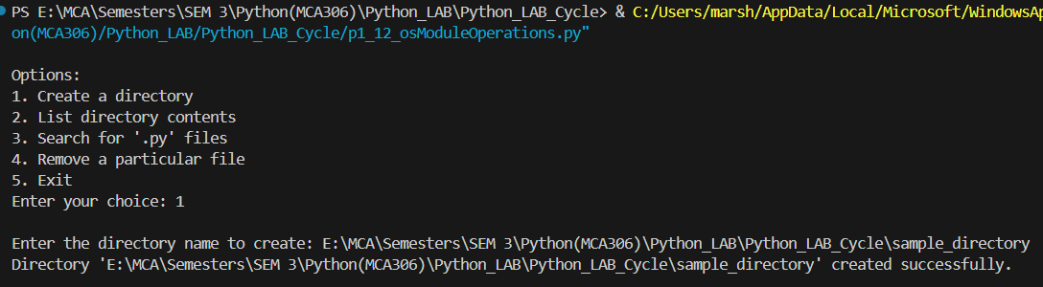
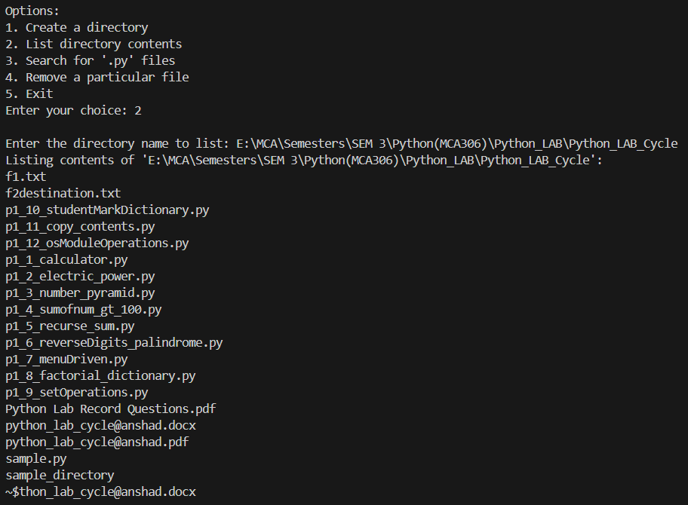

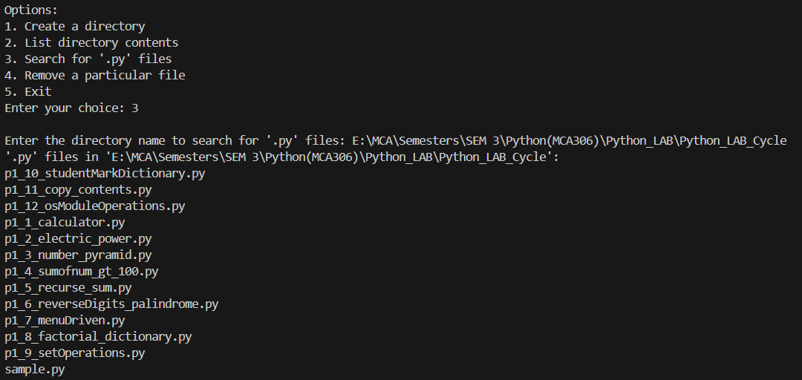
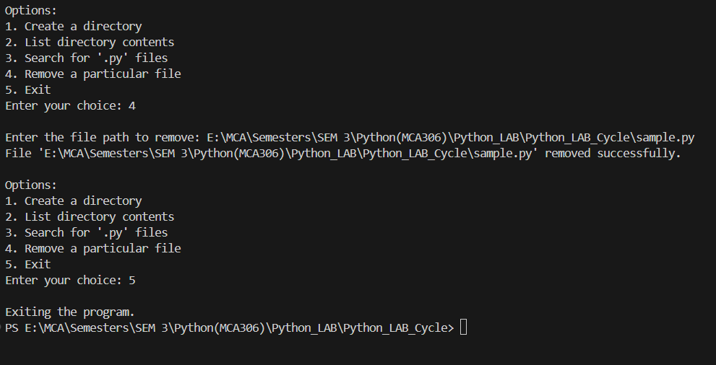

1.13. Create a simple banking application by using inheritance.

PROGRAM :
#Create a simple banking application by using inheritance.

class Account:
def __init__(self, owner, balance=0.0):
self.owner = owner
self.balance = balance

def deposit(self, amount):
if amount > 0:
self.balance += amount
print(f"Deposited {amount}. New balance is {self.balance}.")
else:
print("Deposit amount must be positive.")

def withdraw(self, amount):
if amount > 0:
if self.balance >= amount:
self.balance -= amount
print(f"Withdrew {amount}. New balance is {self.balance}.")
else:
print("Insufficient funds.")
else:
print("Withdrawal amount must be positive.")

def display_balance(self):
print(f"Account owner: {self.owner}, Balance: {self.balance}")

class SavingsAccount(Account):
def __init__(self, owner, balance=0.0, interest_rate=0.01):
super().__init__(owner, balance)
self.interest_rate = interest_rate

def add_interest(self):
interest = self.balance * self.interest_rate
self.balance += interest
print(f"Interest added. New balance is {self.balance}.")

class CurrentAccount(Account):
def __init__(self, owner, balance=0.0, overdraft_limit=500):
super().__init__(owner, balance)
self.overdraft_limit = overdraft_limit

def withdraw(self, amount):
if amount > 0:
if self.balance + self.overdraft_limit >= amount:
self.balance -= amount
print(f"Withdrew {amount}. New balance is {self.balance}.")
else:
print("Overdraft limit exceeded.")
else:
print("Withdrawal amount must be positive.")

def main():
accounts = {}

while True:
print("\nBanking System Menu:")
print("1. Create Savings Account")
print("2. Create Current Account")
print("3. Deposit")
print("4. Withdraw")
print("5. Display Balance")
print("6. Add Interest (Savings Account only)")
print("7. Exit")

choice = input("\nEnter your choice: ")

if choice == '1':
owner = input("\nEnter account owner's name: ")
balance = float(input("\nEnter initial balance: "))
interest_rate = float(input("\nEnter interest rate: "))
accounts[owner] = SavingsAccount(owner, balance, interest_rate)
print("\nSavings account created successfully.")

elif choice == '2':
owner = input("\nEnter account owner's name: ")
balance = float(input("\nEnter initial balance: "))
overdraft_limit = float(input("\nEnter overdraft limit: "))
accounts[owner] = CurrentAccount(owner, balance, overdraft_limit)
print("\nCurrent account created successfully.")

elif choice == '3':
owner = input("\nEnter account owner's name: ")
if owner in accounts:
amount = float(input("\nEnter amount to deposit: "))
accounts[owner].deposit(amount)
else:
print("\nAccount not found.")

elif choice == '4':
owner = input("\nEnter account owner's name: ")
if owner in accounts:
amount = float(input("\nEnter amount to withdraw: "))
accounts[owner].withdraw(amount)
else:
print("\nAccount not found.")

elif choice == '5':
owner = input("\nEnter account owner's name: ")
if owner in accounts:
accounts[owner].display_balance()
else:
print("\nAccount not found.")

elif choice == '6':
owner = input("\nEnter account owner's name: ")
if owner in accounts:
account = accounts[owner]
if isinstance(account, SavingsAccount):
account.add_interest()
else:
print("\nInterest can only be added to savings accounts.")
else:
print("\nAccount not found.")

elif choice == '7':
print("\nExiting the program.")
break
else:
print("\nInvalid choice. Please try again.")

if __name__ == "__main__":
main()

OUTPUT:
PS E:\MCA\Semesters\SEM 3\Python(MCA306)\Python_LAB\Python_LAB_Cycle> & C:/Users/marsh/AppData/Local/Microsoft/WindowsApps/python3.11.exe "e:/MCA/Semesters/SEM 3/Python(MCA306)/Python_LAB/Python_LAB_Cycle/p1_13_bankingApp.py"

Banking System Menu:
1. Create Savings Account
2. Create Current Account
3. Deposit
4. Withdraw
5. Display Balance
6. Add Interest (Savings Account only)
7. Exit

Enter your choice: 1

Enter account owner's name: Anshad

Enter initial balance: 15000

Enter interest rate: 8

Savings account created successfully.

Banking System Menu:
1. Create Savings Account
2. Create Current Account
3. Deposit
4. Withdraw
5. Display Balance
6. Add Interest (Savings Account only)
7. Exit

Enter your choice: 2

Enter account owner's name: Dilsha C P

Enter initial balance: 25000

Enter overdraft limit: 50000

Current account created successfully.

Banking System Menu:
1. Create Savings Account
2. Create Current Account
3. Deposit
4. Withdraw
5. Display Balance
6. Add Interest (Savings Account only)
7. Exit

Enter your choice: 3

Enter account owner's name: Anshad

Enter amount to deposit: 20000
Deposited 20000.0. New balance is 35000.0.

Banking System Menu:
1. Create Savings Account
2. Create Current Account
3. Deposit
4. Withdraw
5. Display Balance
6. Add Interest (Savings Account only)
7. Exit

Enter your choice: 4

Enter account owner's name: Dilsha C P

Enter amount to withdraw: 5000
Withdrew 5000.0. New balance is 20000.0.

Banking System Menu:
1. Create Savings Account
2. Create Current Account
3. Deposit
4. Withdraw
5. Display Balance
6. Add Interest (Savings Account only)
7. Exit

Enter your choice: 5

Enter account owner's name: Anshad
Account owner: Anshad, Balance: 35000.0

Banking System Menu:
1. Create Savings Account
2. Create Current Account
3. Deposit
4. Withdraw
5. Display Balance
6. Add Interest (Savings Account only)
7. Exit

Enter your choice: 6

Enter account owner's name: Dilsha C P

Interest can only be added to savings accounts.

Banking System Menu:
1. Create Savings Account
2. Create Current Account
3. Deposit
4. Withdraw
5. Display Balance
6. Add Interest (Savings Account only)
7. Exit

Enter your choice: 6

Enter account owner's name: Anshad
Interest added. New balance is 315000.0.

Banking System Menu:
1. Create Savings Account
2. Create Current Account
3. Deposit
4. Withdraw
5. Display Balance
6. Add Interest (Savings Account only)
7. Exit

Enter your choice: 7

Exiting the program.
PS E:\MCA\Semesters\SEM 3\Python(MCA306)\Python_LAB\Python_LAB_Cycle>

- Database Operations
2.1. Implementation of MySQL connection using Python.

PROGRAM :
#2.1 : Program to implement database using mysql

#Step 1 : import mysql connector
import mysql.connector
#Step 2 : Establish connection
con = mysql.connector.connect(
host="localhost",
user="root",
password="",
database="python_test"
)
#Step 3 : Create cursor
mycursor = con.cursor()
#Step 4 : Create table
mycursor.execute("CREATE TABLE students(name VARCHAR(255),age int)")
#Step 5 : Insert data to table
#a)Inserting single row
mycursor.execute("INSERT INTO students(name,age) VALUES('Anshad',24)")
#b)Inserting Multiple row
sql = "INSERT INTO students(name,age) VALUES(%s,%s)"
val = [
('Dilsha C P',23),
('Nihal',22),
('Majo',22),
('Mariya',22)
]
mycursor.executemany(sql,val)
#Step 6:Commit changes
con.commit()
print(mycursor.rowcount," Was Inserted.")
#Step 7:Select Data from Table
mycursor.execute("SELECT * from students")
myresult = mycursor.fetchall()
for x in myresult :
print(x)
mycursor.close()
con.close()

2.2. Implementation of SqLite connection using Python.

PROGRAM :
#2.2 : Program to implement database using sqlite3

# Step 1 : import sqlite connector
import sqlite3
from sqlite3 import Error
import os

def connect_to_sqlite(db_file):
conn = None
try:
# Step 2 : Establish connection
conn = sqlite3.connect(db_file)
print(f"Connected to SQLite, SQLite version: {sqlite3.version}")
# Step 3: Create a cursor
cursor = conn.cursor()

# Step 4 :Creating Tables
# a) Create table 'users' (For multiline query use ('''))
cursor.execute('''CREATE TABLE IF NOT EXISTS users (
id INTEGER PRIMARY KEY,
name TEXT NOT NULL
);''')

# b) Create table 'students'
cursor.execute("CREATE TABLE IF NOT EXISTS students (id INTEGER PRIMARY KEY, Name TEXT NOT NULL, Age INTEGER);")
# Step 5 : Insert Values to Table

# a) Insert values to 'users' table
cursor.execute("INSERT INTO users (name) VALUES ('Anshad');")
val = [
('Dilsha C P',),
('Nihal',),
('Majo',)
]
cursor.executemany('INSERT INTO users (name) VALUES (?)', val)
# b) Insert values to 'students' table
val2 = [
('Anshad', 24),
('Dilsha C P', 23),
('Nihal', 22),
('Majo', 22)
]
cursor.executemany('INSERT INTO students (Name, Age) VALUES (?, ?)', val2)
# Step 6 : Commit the transactions
conn.commit()
# Step 7: Fetching rows from table
# a) Fetch from 'users' table
cursor.execute("SELECT * FROM users;")
rows = cursor.fetchall()
print("\nData from the users table are:\n")
for row in rows:
print(row)

# b) Fetch from 'students' table
cursor.execute("SELECT * FROM students;")
rows = cursor.fetchall()
print("\nData from the students table:\n")
for row in rows:
print(row)
except Error as e:
print(f"Error connecting to SQLite: {e}")
finally:
if conn:
conn.close()
print("SQLite connection is closed")
if __name__ == "__main__":
# Use an absolute path for the database file
db_path = "E:\MCA\Semesters\SEM 3\Python(MCA306)\Python_LAB\Python_LAB_Cycle\DB_sqlite3.db"
connect_to_sqlite(db_path)

# Check if the file was created
if os.path.exists(db_path):
print(f"Database file '{db_path}' was created successfully.")
else:
print(f"Failed to create the database file '{db_path}'.")

2.3. Write a program to implement CRUD operations using Python.

PROGRAM :
#2.3 : program to implement CRUD operations using Mysql

#Step 1 : import
import mysql.connector
from mysql.connector import Error
#Step 2 : Set Path
db_config = {
'host' : 'localhost',
'user' : 'root',
'password' : '',
'database' : 'db_python'
}
#Step 3 :Establish Connection
def create_connection(config):
conn = None
try:
conn = mysql.connector.connect(**config)
if conn.is_connected():
print("Connection Established")
except Error as e:
print(e)
return conn
#Step 4 : Create Table
def create_table(conn):
try:
cmd = '''CREATE TABLE IF NOT EXISTS student (
id INT AUTO_INCREMENT PRIMARY KEY,
name VARCHAR(255) NOT NULL,
email VARCHAR(255) NOT NULL
);
'''
cursor = conn.cursor()
cursor.execute(cmd)
conn.commit()
print("Table Created/Already Exists")
except Error as e:
print(e)
#Step 5 : Insert Values to Table
def insert_student(conn,student):
try:
cmd = '''INSERT INTO student(name,email) VALUES (%s,%s)'''
cursor = conn.cursor()
cursor.execute(cmd,student)
conn.commit()
print("Student inserted.")
except Error as e:
print(e)

#Step 6:Read values from table
def read_student(conn):
try:
cmd = "SELECT * from student"
cursor =conn.cursor()
cursor.execute(cmd)
rows = cursor.fetchall()
for row in rows:
print(row)
except Error as e :
print(e)
#Step 7:Update Values
def update_student(conn,student_id,new_name):
try:
cmd="UPDATE student SET name = %s WHERE id = %s"
cursor = conn.cursor()
cursor.execute(cmd,(new_name,student_id))
conn.commit()
print("Student updated.")
except Error as e:
print(e)

#Step 8 :Delete values
def delete_student(conn,student_id):
try:
cmd = "DELETE FROM student WHERE id = %s"
cursor = conn.cursor()
cursor.execute(cmd,(student_id,))
conn.commit()
print("Student deleted.")
except Error as e:
print(e)
def main():
#DB connection
conn = create_connection(db_config)
if conn is not None:
#Create Table
create_table(conn)
#Insert student
insert_student(conn,('Anshad Muhammad','mca2336@rajagiri.edu'))
insert_student(conn,('Dilsha C P','mca2318@rajagiri.edu'))
#Read and Display
print("Students Before update:\n")
read_student(conn)
#Update a student
update_student(conn,1,'Anshad P A')
#Display after update
print("Students after update:\n")
read_student(conn)
#Delete a Student
delete_student(conn,2)
#Display after Deletion
print("Students after deletion:\n")
read_student(conn)

#Close connection
conn.close()
else:
print("Error! Cannot create the database connection.")
if __name__=='__main__':
main()

